-employee performance report

Executive Summary
This report analysis Employee Performance and salary data from Kaggle to gain insights into employee performance and salary. The primary key objectives to assess total salary per department, employee count. The findings will assist the senior management in making informed strategic decision.

Scope
- Employees
- Salary
- Performance

Data specs
Here is the table which used to conduct our analysis:
Employee Performance.

The Analysis

Employees

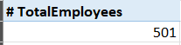
What is the number of active employees?

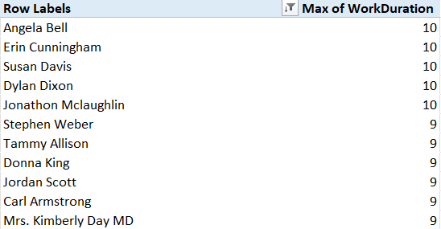
Who are the oldest 10 employees in company in terms of joining date and performance score equal 5?

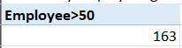
How many employees greater than 50 years?

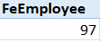
How many females work in the company and their age less than 45?

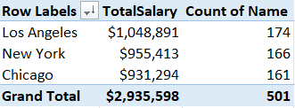
How many employees for each branch?

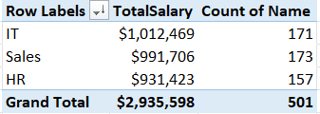
How many employees per department?

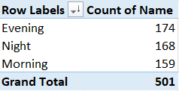
How many employees per session?

Salary
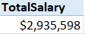
What is the employees’ salary costs?


What is the highest department costs salary?


Which is the highest branch costs salary?

Performance
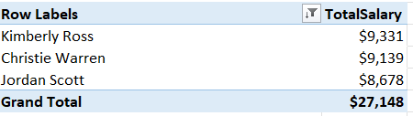
Who are the employees work in sales department have performance score equal 5 and his salary greater than 8000 $?

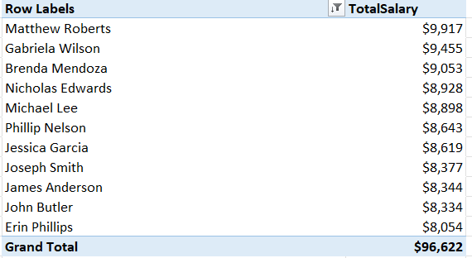
Who are the employees work in sales department have performance score less than 3 and his salary greater than 8000 $?

